SACRED HEART PARISH

Sacred Heart Parish Founded 1814, The First Catholic Parish in the STate of New Jersey

Sacred Heart Church, 343 South broad Street, Trenton, New Jersey 08608

Holy Cross Church, 233 Adeline Street, Trenton, New Jersey 08611

ALL ARE WELCOME

Whatever your present status in the Catholic Church, whatever your current family or marital situation,

Whatever your past or present religious affiliation, whatever your personal history, age, background, or

race, whatever your own self-image or esteem, you are invited, welcomed, accepted, loved and

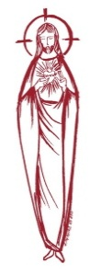
respected at the Parish of the Sacred Heart.

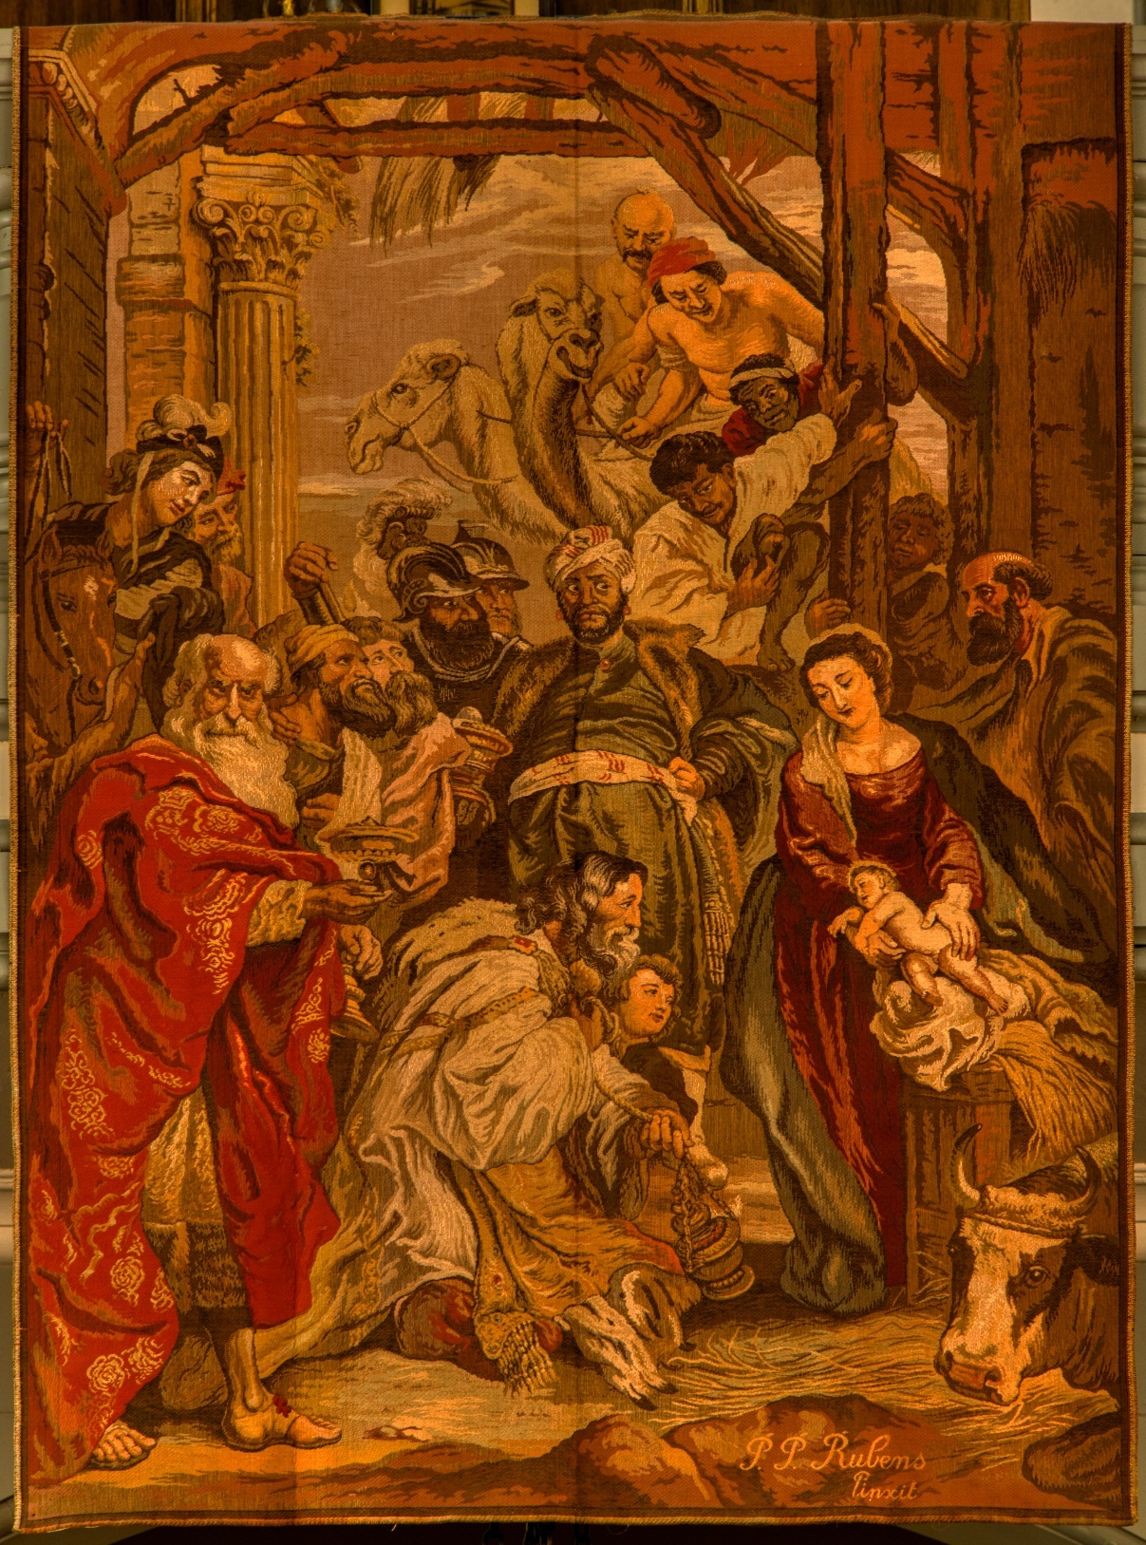

FOURTH SUNDAY OF ADVENT ~ DECEMBER 24, 2023
CHRISTMAS ~ DECEMBER 25, 2023

MASS INTENTIONS
Saturday, December 23
4:00 pm ~ Thomas & Pauline Lukowicz
5:15 pm SHC ~ Anna Vispetti
Sunday, December 24
10:00 SH ~ For the Deceased Priests of the Parish
10:00 HCC ~ For the People of the Parish
12:00 HCC Polish~ For Deceased Religious of the Parish
Sunday, December 24 ~ Christmas Eve Masses
4:00pm ~ Christmas Intentions
4:15pm SHC ~ Lessons and Carols
5:15pm SHC ~ Christmas Intentions
12:00 Midnight SHC ~ Christmas Intentions
Monday, December 25 ~ Christmas Masses
9:00 SH ~ Christmas Intentions
10:00 HCC ~ Christmas Intentions
11:15 SHC ~ Christmas Intentions
12:00 HCC Polish~ Christmas Intentions
Tuesday, December 26
12:10 pm SHC ~ No Mass
Wednesday, December 27
12:10 pm SHC ~ Carl Amoroso
Thursday, December 28
8:00 am HCC ~ Philomena William Cracker
Friday, December 29
8:00 am HCC ~ No Mass
12:10 pm SHC ~ No Mass
Saturday, December 30
4:00 pm ~ Eileen Kostrzewa
5:15 pm SHC ~ Nancy Koerwer
Sunday, December 31
10:00 SH ~ For the People of the Parish
10:00 HCC ~ For Thanksgiving
12:00 HCC Polish~ Ks. Kanonik Jan Majka
Sunday, December 31 ~ New Year’s Eve Masses
4:00pm ~ For the People of the Parish
5:15pm SHC ~ For the People of the Parish
Monday, January 1 ~ New Year’s Day
10:00 SH ~ For the People of the Parish
10:00 HCC ~ For the People of the Parish
12:00 HCC Polish~ For the People of the Parish

WEEKLY COLLECTION
Last weekend’s will be announced next weekend.

READINGS FOR THE WEEK
Fourth Week of Advent
Sunday 2 Sm 7:1-12, 14a, 16; Rom 16:25-27; Lk 1:26-38
Tuesday Acts 6:8-10, 7:54-59; Mt 10:17-22
Wednesday 1 Jn 1:1-4; Jn 20:1a, 2-8
Thursday 1 Jn 1:5—2:2; Mt 2:13-18
Friday 1 Jn 2:3-11; Lk 2:22-35
OUR SICK LIST
Stanley Sniadach, Kristen Topley, Mary Sokolowski, Rocco, Lorraine Wargo, Robert Paci, Mrs. Loatman, David Carver, Jennifer Lyons, Grace Profy, Steve Jurczynski, Cornell Hess, Ruby Covington, Judith Santigo, Ching Kukis, Dan Breese Jr, Brenna Kennedy-Moore, Dawn Chia, Mark Friedman, Alexander A. Ladnyk, Kelly Nitti, Lauren Clayton, Joseph Edralin, Margie Tiongson, Kevin, Vincent Cooper, Jr., Gail Ladnyk, Leo Genovesi, Sloane Donnelly, Richard Buckley, Tony Ragolia, Barbara Burrows, Charles Burrows, Dorothy Amoroso, Maryann Sullivan, Regina Friedman, Stanley Winowicz, Greg Schafer, Jack Hardiman, Amy Birk, Julia Grazioli, Matt Tydryszewski.
OUR DECEASED
John Convenio, Ann Apoldite, Robin Haynes, Betty O’Neill, Susan Cuniglio, Wilma Ruberto, and our friends at South Village, Riverside Nursing and Rehabilitation Center, Mill House and Waters Edge.

MINISTRY SCHEDULE
Saturday, December 23
4:00pm HCC ~ Fr Charles L. C. Benitez Em. N. Saganowski
5:15pm SHC ~ Msgr. Dennis L. N. Kazior Em. J. Kazior & R. Hoyer
Sunday, December 24
10:00 SHC ~ Msgr. Dennis L. A. Urbaniak Em. J. Ellie & A. Green
10:00 HCC ~ Fr. Charles L. M. Days Em. F. Zielinski
12:00 HCC Polish ~ Fr. Marian Gosia, Ewa

CHRISTMAS EVE
4:00 HC Fr Charles L M Herpel Em. L. Bliznawiczus
5:15 SH Msgr Dennis L K Willever Em A Solack , J Kaizor
12:00 Midnight L. M Tovar Ems J & J DeSantis
CHRISTMAS DAY
9:00 SH Msgr Dennis L J Laurenti EM M Komjathy K Jurczynski
11:15 SH Msgr Dennis L. J Blizard EMS NEEDED
10:00 HC Fr Charles L Needed, EM NEEDED
12:00 HC Polish Fr Marian L & Em Anna, Grazyna

Saturday, December 30
4:00pm HCC ~ Fr Charles L. R. Micharski Em. C. Benitez
5:15pm Msgr. Dennis L. L. Bellina, Em. W. Lewis & M. Salamandra
Sunday, December 31
10:00 SHC ~ Msgr. Dennis L. K. Valentino Em. H. & M. Figueroa
10:00 HCC ~ Fr. Charles L. F. Kollie Em. D. Ezeuka
12:00 HCC Polish ~ Fr Marian Ewa, Mieciu

2023 ANNUAL CATHOLIC APPEAL UPDATE
Goal: $33,000.00
Pledged: $46,592.00 (141% of Goal)
PROMISE TO PROTECT
The Diocese of Trenton is committed to the norms of the U.S. Bishop’s Charter for the Protection of Children and Young People in regard to the reporting and investigation of sexual abuse allegations involving minors. If you have been sexually abused as a minor by anyone representing the Catholic Church, you can report that abuse through the diocesan Hotline: 1-888-296-2965 or abuseline@dioceseoftrenton.org. Allegations are reported to the appropriate law enforcement agencies.
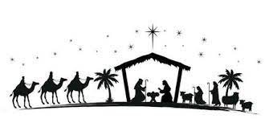

CHRISTMAS BLESSINGS

O Sweet Child of Bethlehem,
Grant that we may share
with all our hearts
in this profound mystery of Christmas.
Put into the hearts of men and women,
this peace for which they sometimes
seek so desperately and
which you alone can give to them.
Help them to know one another better,
and to live as brothers and sisters,
children of the same Father.
Reveal to them also
your beauty, holiness, and purity.
Awaken in their hearts love and gratitude for your infinite goodness.
Join them all together in your
love and give us your heavenly peace.

We echo these words
of Pope St. John XXIII, and pray
this prayer for every member of the family of Sacred Heart Parish.

May you have the gift of Faith,
the Blessing of Hope, and the Peace of His Love at the Christmas Season
and always.
Christmas Blessings,
Msgr. Dennis, Fr. Charles and Staff

CHRISTMAS SCHEDULE 2023

SACRED HEART CHURCH
Saturday, December 23
5:15 PM Vigil Mass
Sunday, December 24
10:00 AM
The Nativity of the Lord ~ CHRISTMAS EVE
4:15 PM Christmas Presentation
Lessons and Carols
5:15 PM and 12:00 Midnight Mass
Monday, December 25 ~ CHRISTMAS DAY
9:00 AM and 11:15 AM
Tuesday, December 26 No Mass

HOLY CROSS CHURCH
Saturday, December 23
4:00 PM Vigil Mass
Sunday, December 24
10:00 AM and 12:00 Noon Polish
The Nativity of the Lord ~ CHRISTMAS EVE
4:00 PM
Monday, December 25 ~ CHRISTMAS DAY
10:00 AM Gospel and 12:00 Noon ~ Polish

NEW YEAR SCHEDULE
SACRED HEART CHURCH
Saturday, December 30 5:15 PM Vigil Mass
Sunday, December 31 10:00 AM
Feast of Mary, Mother of God ~
NEW YEAR’S EVE
Sunday, December 31 5:15 PM
Monday, January 1 ~ NEW YEAR’S DAY 10:00 AM

HOLY CROSS CHURCH
Saturday, December 30 4:00 PM Vigil Mass
Sunday, December 31
10:00 AM and 12:00 Noon
Feast of Mary, Mother of God
Sunday, Dec. 31 NEW YEAR’S EVE 4:00 PM
Monday, January 1 ~ NEW YEAR’S DAY
10:00 AM Gospel Mass
12:00 Noon Polish Mass

FRONT COVER

The Adoration of the Magi, 1624
Peter Paul Rubens was the most versatile and influential Baroque artist in Northern Europe in the seventeenth century. This Adoration of the Magi is one of his earliest masterpieces in the High Baroque style he developed after 1620. The Virgin and her Child are the focal point of this adoration, but, contrary to tradition, they are not placed in the middle of the canvas. In religious painting, the adoration of the Messiah by the Wise Men from the East had become a static scene. Here, Rubens has transformed the scene into an image full of motion, with a great variety of poses, expressions, gestures and flowing garments, all of which draws the spectator’s gaze to the protagonists, the Virgin and Jesus. This suggestion of motion is further heightened by forceful and creative brushwork, with blurred contours and colors that blend into each other, almost as in an oil sketch. The lively asymmetrical composition, sophisticated coloring and spontaneity of execution make this monumental altarpiece by Rubens into a dynamic and decorative masterpiece of the Flemish High Baroque.
This piece of art was later configured on tapestry and hangs off the choir loft in Sacred Heart Church.

BLESSING OF HOMES
The Blessing of Homes will take place this year during the month of January. The Blessing includes a prayer that God will protect your family during the coming year. Your home will sprinkled with holy water and the initials of the Three Kings who visited and worshipped the Infant Jesus in Bethlehem are written above the lintel of the main door with blessed chalk (Caspar, Melchior, and Balthasar). If you are a registered parishioner and wish to have your home blessed, please complete the form below and return it in the collection basket or drop it off at the Parish Office.
Name __________________________________________
Address___________________________City________
Cell or phone number __________________
VOLUNTEER PARTY
The “Little Christmas” Volunteer Appreciation Party, will be held Friday evening, January 5th from 6:00 - 9:00 pm. We will begin with a prayer service at 6:00 pm in Sacred Heart Church followed by light refreshments in Msgr. Toomey Hall. All those who volunteer are invited. Please R.S.V.P. by December 28th by calling the office at 609-393-2801 or by filling out the form below and place in the collection basket. Thank you.

VOLUNTEER PARTY
Name _______________________________
Number attending______________________
Cell or phone number __________________
FOURTH SUNDAY OF ADVENT
~ THE FOURTH CANDLE ~
Reflection: The angel announces to Mary, “You shall bear a son whose name will be Emmanuel,” which means, God is with us. With Mary, we are called to be Christ bearers. With her we wonder, “How can this be?” As Christmas draws near, let us open our hearts in trust to the power of the Holy Spirit who comes upon us. Let us join Mary in saying, “Be it done unto me according to your will.” (Light all four candles.)
Scripture: “Blessed are you among women, and blessed is the fruit of your womb, Jesus...Blessed is she who trusted that the Lord’s word to her would be faithful”(Luke 1:42,45).
Prayer: Jesus, you are the light of the world. Yet you were born in the darkness of night, in a cold stable with only the animals to warm you. Let the light of your love shine on us so we can see you today in all the helpless children, in all who have no home. Teach us how to love you in them. Response: Come, Lord Jesus!

BLOOMIN’ 4 GOOD PROGRAM
Sacred Heart’s Food Outreach Program has been selected by Stop & Shop to benefit from the Bloomin’ 4 Good Program. Our food pantry will receive $1 from every specially marked $10.99 Bloomin 4 Good bouquet sold during the month of December 2023 at the Stop & Shop located at 800 F Denow Road, Pennington NJ.
SWEAT SOCK DRIVE
It’s that time of year when we need to think about the street people in our area who are in need of clean sweat socks. On the weekend of January 23rd and 24th we ask you to bring to the altar rail sweat socks for the needy. We ask that you do not bring ankle socks. They will be distributed to the street people of Trenton. Thank you.

CONTRIBUTION STATEMENTS
Those interested in receiving a statement documenting contributions made in 2023, please fill out the bottom portion of this notice and return it to the parish office in the collection basket or to secretary@trentonsacredheart.org. A copy of your contribution statement will be mailed to you by the end of the month. If there are discrepancies please be sure to notify us and we will make the adjustments. It would help us if you filled in the amount donated.
Envelop # _________________________________________
Amount Donated _________________________________
Name _____________________________________________
Address___________________________________________
___________________________________________________

ALTAR ROSARY SOCIETY
All rosarians, future rosarians, people of our parish are warmly welcomed to join us on Sunday, January 7th, 9:00am Mass at Sacred Heart Church. The Rosary will be prayed before Mass. Following Mass, a meeting will take place at Toomey Hall. Stop by, meet the members and enjoy light refreshments. We are a church support group of dedicated Catholic people who serve our Blessed Mother, our Parish community. God Bless you all. We are looking forward to your participation. Any questions, please call Joan Buckley @ 609 396 7063. We wish you all a Happy, blessed, safe, New Year.

Be sure to check our web page for our weekly bulletin at www.Trentonsacredheart.org

Christmas Blessings

THE MIRACLE OF CHRISTMAS
SIGHT AND SOUND, LANCASTER
Our Seniors Group has planned a bus trip for Friday, December 29, 2023, to the Sight and Sound Theatre in Lancaster, PA to see “The Miracle of Christmas”. The bus will leave Sacred Heart Church parking lot at 8:00 am and return by 6:30 pm. Please arrive and check in by 7:45am.
We will not have the 8:00am or 12:10 pm Masses this Friday due to our bus trip.

THE NATIVITY ~ 800th ANNIVESARY
Francesco Bernardone, son of a wealthy merchant in Assisi, was born in 1181. He was an outgoing and popular young man, enjoying an active social life with his friends. He eventually began a journey of discernment and conversion about the meaning of his life. Francis eventually renounced his inheritance and gave himself over to Christ and the Church. He became known as “Il Poverello,” the little poor one, spending the rest of his life living the Gospel message of Christ.
Francis, living a life of poverty, preached to the people of the countryside about penance, brotherly love, and peace. In 1223, feeling that the people had forgotten the Gospel story that Jesus came as a poor child, born in a stable, not as a rich king, he wrote to his friend Giovanni, “I want to do something that will recall the memory of that child who was born in Bethlehem, to see with bodily eyes the inconveniences of His infancy, how He lay in the manger, and how the ox and ass stood by.”
He created a living Nativity scene in a cave at Greccio, a small town on a hill in Italy, inviting the villagers to visit while he preached about “the babe of Bethlehem.” God had come to earth as a baby, one of us, to be loved and cared for. The first Nativity scene and the tradition of celebrating “Greccio” had begun.
Franciscans all over the world celebrate Greccio with a ritual involving a procession, readings, and simple song, concluding in prayer and sacred silence at a Nativity, or creche, scene. This year, 2023, marks the 800th year of Greccio and is one of several centenary milestones being commemorated by Franciscans.

SOME IDEAS ABOUT THE NATIVITY SCENE TAKEN FROM THE INTERNET

Disposition of a Christmas crib The scientific advisors of the crib museums discovered in their research that each crib figure had been assigned a specific place since the Middle Ages.

Jesus in the center of attention The baby Jesus is always in the center and all the other characters are positioned around the crib. Care must be taken that the back of the child remains generally free, where there is no one, neither a person nor an animal.

Left side: Mary, the ox, the shepherd, and the sheep May is sitting or kneeling to the right of the child. Seen by the spectator, she is on the left. Behind or next to her is the ox, which does not actually appear in Luke's Gospel but is considered a kosher animal and symbolizes the people of Israel and Christianity. From the left, i.e. from Mary's side, the shepherds approach with their sheep. They represent the believers who bring sacrificial animals, food and clothing.

The right side: Joseph, the donkey, the three wise men Joseph is on the left side of the baby Jesus, that is, on the right if seen by the viewer. Next to Joseph is the donkey, also not mentioned in Luke's Gospel. The donkey is interpreted as an impure animal and symbolizes non-religious or even pagan people. Therefore, also the three wise men. Gaspar, Melchior and Balthazar are the "wise men of the East" who donate gold, incense and myrrh. With youth, middle age and old age, they are on the one hand a symbol for the different stages of people's lives. On the other hand, their origins from Africa, Asia and Europe are associated with the three continents known at the time.

The Nativity Stable The stable serves as an improvised shelter and is mentioned in both the Gospels of Luke and Matthew. Nowhere else can Mary and Joseph find a place to stay. In this stable, according to the Christmas story, the baby Jesus is born. Since she has no other bed, Mary puts the baby in a manger full of hay.

What is the meaning and Significance of the Manger? The Gospel of Luke gives us a play-by-play of the moments leading up to our Savior’s birth. Although that divine narrative explains Mary and Joseph’s journey to Bethlehem and the circumstances surrounding the blessed event, Scripture gives us only one detail about where our Savior spent His first moments on earth. He was laid in a manger for ALL to see.

What Is a Manger? If Luke had been a typical author, he might have added nuance to Jesus’s birth story to make the setting come alive for the reader. Or he may have embellished the plot to increase tension so that the reader would want to turn the page. But because we know God inspires all Scripture, we can be sure that the Holy Spirit had a purpose for every detail conveyed. When Jesus was born, Luke tells us that Mary laid him in something called a manger. The word used for manger is the Latin word munducare, which means “to eat.” When our Savior left the comfort of Heaven and his earthly mother’s womb, his first resting place on earth doubled as a feeding trough for livestock. Back then, farmers kept their mangers overflowing with fodder so their beasts of burden would never go hungry. After Mary tucked our swaddled Savior securely in his trough, an angel of the Lord appeared to a herd of nearby shepherds. The angel issued Jesus’s glorious birth announcement to them along with an invitation to a birthday feast. “Today in the town of David a Savior has been born to you; he is the Messiah, the Lord. This will be a sign to you: You will find a baby wrapped in cloths and lying in a manger” The shepherds, overjoyed by the news and overwhelmed with the glory of God, didn’t waste any time accepting the invitation. They stampeded to the trough, eager to satisfy the hunger stirred within them. These shepherds were the first of many who would feast on the presence of the long-awaited Messiah, Christ Jesus our Lord.

